Problem Assignment #6
Simple Computer System with Memory-Mapped Input/Output
ECE 2330 Digital Logic Design
Spring 2022
April 29, 2022
By Kevin Moody (km4ws)

Table of Contents
1 Problem Statement 2
2 Analytical Design 2
3 Numerical Verification 3
4 Summary 3

Table of Figures
Figure 1: Simple CPU Design 2
Figure 2: Simple Computer Design 2
Figure 3: AddressDecoder Design 2
Figure 4: PortRegister Design 2
Figure 5: Simple CPU Test 3
Figure 6: Memory Contents 1 3
Figure 7: Memory Contents 2 3

1 Problem Statement
Develop a hierarchical schematic of a simple computer system. For this design, the SimpleCPU developed in Project 5 is a component that represents the CPU of the computer. To verify that the design functions correctly, a program will be loaded into the EEPROM which tests all eight instructions, tests all components of the Simple CPU, and accesses almost every location in program/data memory. The program is self modifying, in that it modifies the instructions located at Memory Address (MA) 0x13 (dec 25) and 0x15 (inc 25) based on the value of DataMemoryCounter = 6 located at MA 0x19.

2 Analytical Design
In this assignment, we used the four major components from our CPU (InstructionSequencer, Opcode Decoder, Control Signals, and DataPath), and brought them all together to form a CPU that takes a clock, reset, and 8-bit DataBus input, and outputs AddressBus, Read, and Write (shown in Figure 1). This SimpleCPU was then added to the overall Simple Computer file, shown in Figure 2. This simple computer also used an AddressDecoder and a PortRegister, shown in Figures 3 and 4. The PortRegister had a DataOut output that lead to a seven-segment hex display which can be used to verify the functionality of some functions.
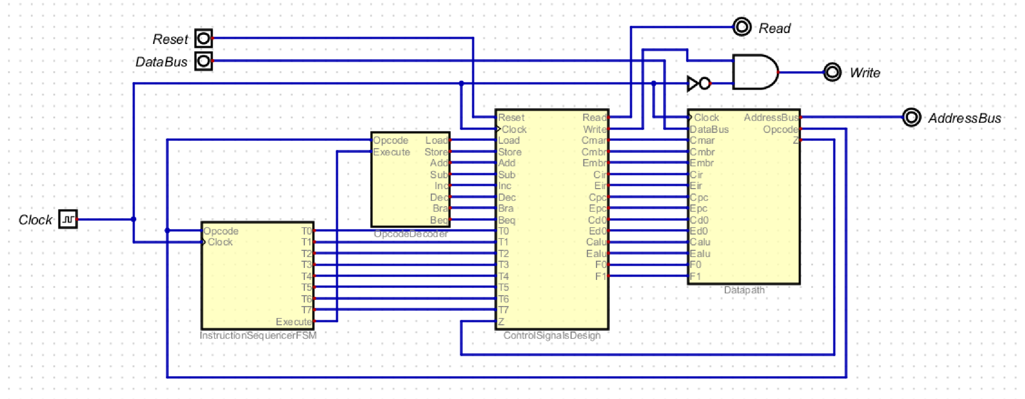

Figure 1: SimpleCPU Design
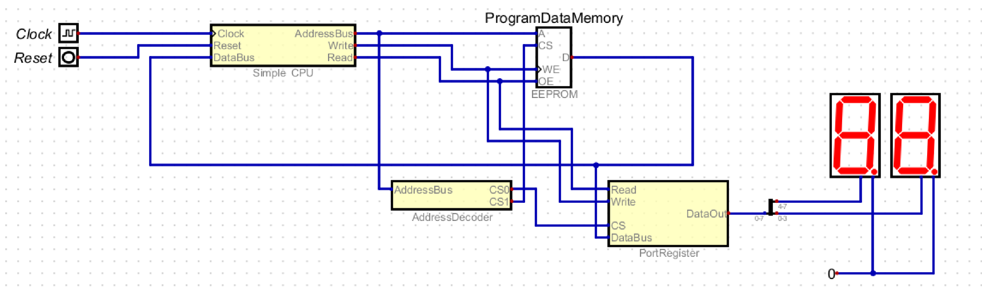

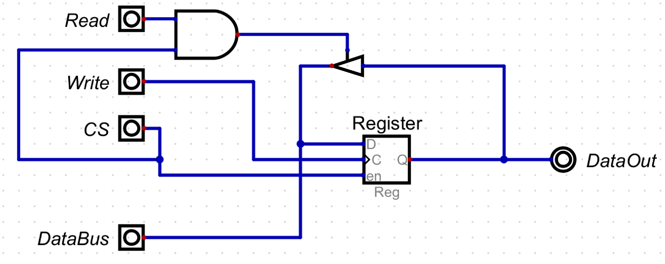
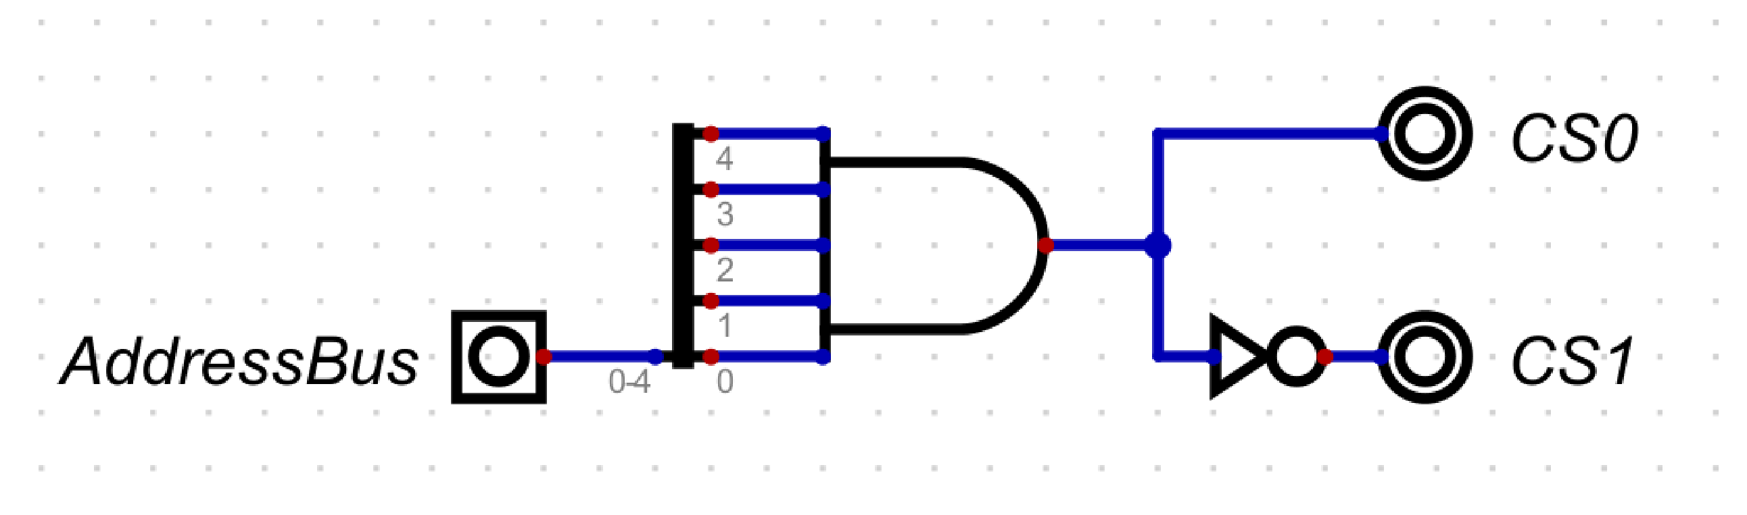
Figure 3: AddressDecoder Design
Figure 4: Port Register Design
Figure 2: Simple Computer Design

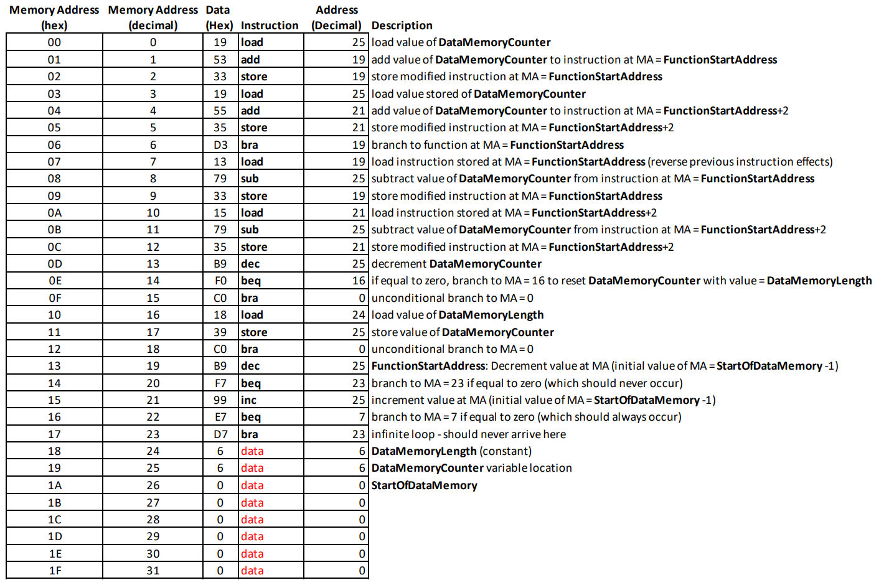
3 Numerical Verification
For this project, two separate methods were used to verify that the simple computer constructed adhered to the guidelines in the project rubric. First, was by using a supplied program, shown in Figure 5. This is a self-modifying program that modifies the instructions located at MA 0x13 and MA 0x15 based on the value at MA 0x19. We were able to verify that this program worked correctly because, when the program has been loaded into the EEPROM, the program memory is restored to its original state after all 6 data locations (0x1A – 0x1F) have been decremented/incremented and DataMemoryCounter (0x19) has been re-initialized (Figure 6).
Figure 5: Simple CPU Test

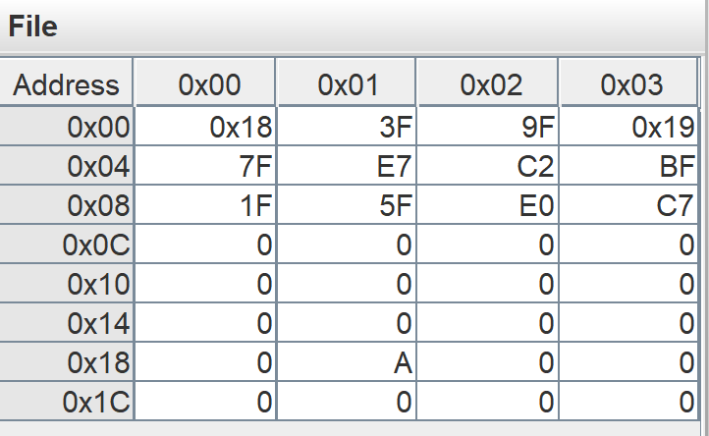
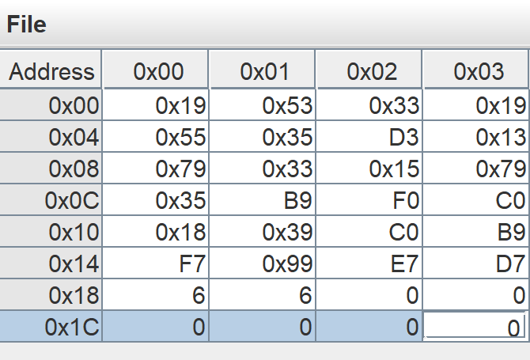
The next method used to verify the functionality of the circuit involves more output than the previous one. The second program will display a value on the two 7-segment displays. The program will continue to increment the value in the display until a value of 0A is reached, then will decrement until the value 00, then begin incrementing again. The program will stay in this cycle of incrementing and decrementing between 00 and 0A until the program is halted. Nothing about the circuits changed between the two programs, however the contents of the EEPROM were to be modified to conduct the new program as opposed to the previous one. This new program can be seen in Figure 7. To further verify designs, please download and run test files on the .dig files provided.
Figure 6: Memory Contents 1

Figure 6: Memory Contents 2
4 Summary
The goal of this project was to successfully bring together entire semesters work of worth, into a single, simple computer. The computer consists of many parts, but most notably are the Datapath, InstructionSequencer, OpcodeDecoder, and ControlSignalsLogic. This project required us to simplify it all into a simple CPU, that took in a Clock, Reset, and DataBus, and outputted an AddressBus, Write, and Read instructions. The functionality of the CPU was verified with both a program provided in the assignment document as well as a program to increment and decrement the value on a 7-segment hex display. Because this computer followed all guidelines and completed all test cases, we can say that we successfully constructed a computer.

